**Owner’s Manual**

**16K Fuzz**

Designed by Michel Keijzers

May 2020

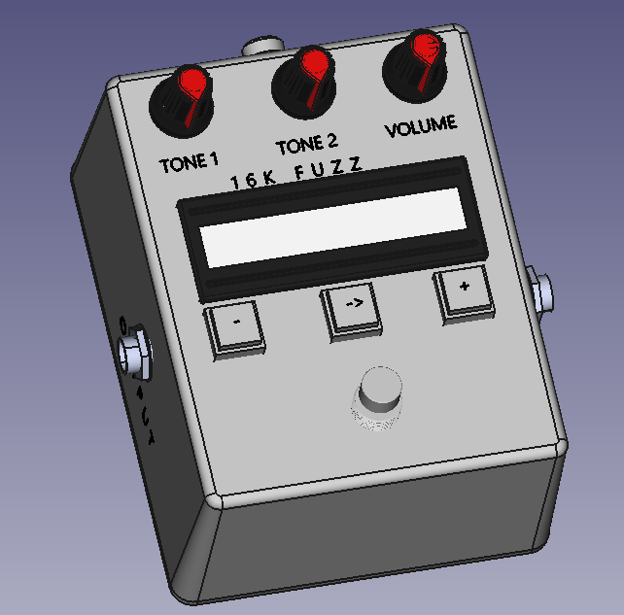

Table of Contents

1 Safety Precautions 3

1.1 Battery power 3

1.2 Power Supply 3

1.3 Product Handling 3

1.4 Operating Environment 3

1.5 Volume 3

2 Usage Precautions 4

2.1 Cleaning 4

2.2 Malfunction 4

3 Terms 5

4 Introduction 6

4.1 Sound 6

4.2 Sound Selection 6

4.3 Capacitors 6

4.4 Transistors 7

5 Operating Instructions 8

5.1 Introduction 8

5.2 Connections 8

5.2.1 Power 8

5.2.2 Guitar In 8

5.2.3 Guitar Out 9

5.3 Digital Part 10

5.3.1 Introduction 10

5.3.2 Preset Selection Mode 11

5.3.3 Capacitor A Mode 12

5.3.4 Transistor B Mode 12

5.3.5 Transistor C Mode 12

5.3.6 Capacitor D Mode 12

5.3.7 Presets Memory Mode 12

5.3.8 Lock/Unlock Mode 13

5.3.9 Bypass Mode 14

5.4 Analog Part 14

5.4.1 Tone 1 Dial Knob 14

5.4.2 Tone 2 Dial Knob 14

5.4.3 Volume Dial Knob 14

6 Technical Specifications 15

7 Contact/Design Information 16

8 Compliances & Warranty 16

List of Tables

Table 1: Terms 5

Table 2: Capacitors 7

Table 3: Transistors 7

Table 4: Push Buttons 10

Table 5: Modes 11

List of Figures

Figure 1: Top View 8

Figure 2: Back View 8

Figure 3: Right View 9

Figure 4: Left View 9

Figure 5: Top View / Digital Part 10

Figure 5: Top View / Analog Part 14

# Glossary

The following terms are used in this manual.

|  |  |
| --- | --- |
| **Term** | **Description** |
| Bypass Switch | Foot switch to enable or disable the fuzz |
| Capacitor | A component that stores energy and defines the sound of the fuzz |
| Component | An electrical component, in this unit: capacitors and transistors. |
| Dial Knob | A rotating dial knob to set a value between a minimum and maximum value used within the analog part of the unit. |
| Preset | A preprogrammed combination of two capacitors and two transistors. |
| Push Button | A button that is pushed by hand to control the digital part of the unit. |
| Transistor | An electrical component used for highly gaining the sound of the fuzz. |

Table : Glossary

# Safety Precautions

## Battery power

* This pedal is not designed to run on battery powered power supplies.
* There is no battery compartment inside. This pedal may not run or not function properly when used with a battery powered voltage supply.

## Power Supply

* Make sure the power supply connector has the internal pin grounded and the outside barrel powered with +9V, preferably using an isolated power supply.
* The minimum current to be supplied by the power supply is 230 mA.

## Product Handling

* Do not drop, bump or apply excessive force to the pedal.
* Do not leak or let foreign objects or liquids to enter the pedal.

## Operating Environment

* Do not use in extremely high or low temperatures.
* Do not use near heaters, stoves and other heat sources.
* Do not use in very humidity or near splashing water.
* Do not use in places with excessive vibrations.
* Do not use in places with excessive dust or sand.

## Volume

* Do not use the product at loud volumes for a long time.

# Usage Precautions

## Cleaning

Use a soft cloth to clean the panels of the pedal if they become dirty. If necessary, use a damp cloth that has been wrung out well. Never use abrasive cleansers, wax or solvents, including alcohol, benzene and paint thinner.

## Malfunction

If the pedal becomes broken or malfunctions, immediately disconnect the adapter and disconnect other cables. Contact the manufacturer for repair.

# Introduction

## Sound

A fuzz pedal takes your sound and clips it extremely hard, which is known as square-wave clipping, compressing the distortion to make an almost unrecognizable sound.

The fuzz pedal heavily saturates your tone and covers it in a wooly, “fuzzy” feel – there is really no better way to describe it. This type of pedal offers a huge amount of sustain by heavily processing your signal and offering a more artificial tone that is entirely its own, which some guitarists feel makes you amplifier sound like its broken.

Fuzz pedals clip so hard that playing anything other than lead lines or single-string riffs sounds a bit weird. However, when you decide to bust out a power chord or huge riff, the amount of power behind them is astonishing. Think about Smashing Pumpkins 'Cherub Rock' which made use of the [EHX Big Muff](http://www.pmtonline.co.uk/electro-harmonix-big-muff-pi-usa-nyc-effects-pedal) and you'll get the idea, or The Stooges song 'I Wanna be Your Dog' to give you an idea of how interesting (and iconic) a fuzz pedal can be. If you turn a guitar amp up loud you will get the sound of an overdrive, if you turn it up full whack you will get distortion - fuzz is the sound of an amp pushed past its maximum into completely unnatural territory and it sounds great!

Jimi Hendrix was perhaps the most famous fuzz pedal player of all time championing the likes of the [Fuzz Face](http://www.pmtonline.co.uk/dunlop-jdf2-fuzz-face-distortion-pedal). Couple it with a [Wah pedal](https://www.pmtonline.co.uk/products/guitar/pedalsandeffects/stompboxes/wahfilterpedals) and you will instantly recognize the sound.

## Sound Selection

This Fuzz pedal can vary sound by selecting different components and by dial knobs.

In a typical fuzz two capacitors and two transistors are used, in this order:

* Capacitor (A)
* Transistor (B)
* Transistor (C)
* Capacitor (D)

In most fuzz pedals, these four components are hard wired. However, in this fuzz, each of the four components can be selected.

The symbols A to D are designators to show which capacitor and which transistor is referred to.

## Capacitors

A capacitor is an electric component that can store small amounts of energy (capacity). The size (capacitance) of a capacitor changes the sound. In this unit, the following capacitors can be selected, both separately for Capacitor A, and Capacitor D:

| **Number** | **Capacitor Size** |
| --- | --- |
| 1 | 10 nF |
| 2 | 33 nF |
| 3 | 100 nF |
| 4 | 470 nF |
| 5 | 1 uF |
| 6 | 2.2 uF |
| 7 | 10 uF |
| 8 | 22 uF |

Table : Capacitors

1 Farad (F) is an enormous amount of capacitance (energy), thus mostly small values used, e.g.:

33 Nano Farad (nF) means 33 x 10-9, which is 0.000,000,033 F.

2.2 micro Farad (µF or uF) means 2.2 x 10-6, which is 0.000,002,2 F.

## Transistors

A transistor is an electric component that can be used for amplifying a current many times, typically between tens to hundredth’s times. A transistor defines together with the capacitors the sound of the fuzz. In this unit, the following transistors can be selected, both separately for Transistor B and Transistor D:

|  |  |  |
| --- | --- | --- |
| **Number** | **Transistor Type** | **Package** |
| 1 | MMBT2222A | SMD |
| 2 | MMBT3904 | SMD |
| 3 | MMBT5551L | SMD |
| 4 | MMBTA42 | SMD |
| 5 | BC807-40 | SMD |
| 6 | BC846B | SMD |
| 7 | BC847B | SMD |
| 8 | BC847C | SMD |
| 9 | BC848B | SMD |
| 10 | S9013 | SMD |
| 11 | S9018 | SMD |
| 12 | C945 | SMD |
| 13 | 2SC1623 | SMD |
| 14 | 2SC1815 | SMD |
| 15 | MPSA18 TH | Through Hole |
| 16 | 2N5088 TH | Through Hole |

Table : Transistors

# Operating Instructions

## Introduction

This pedal contains of two parts, a digital and analog part. The digital part is used to select the components (two capacitors and two transistors), the analog part is the actual guitar sound going through the components.

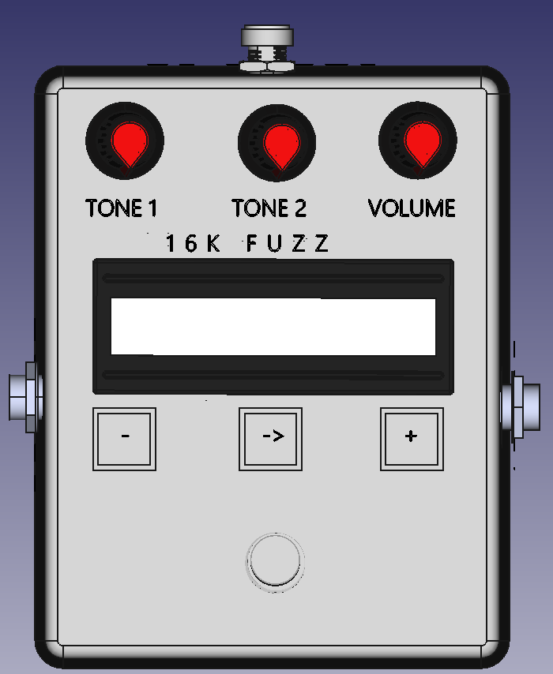

Figure : Top View

## Connections

### Power

The power connection on the back of the Fuzz. A typical power barrel connection port is present, with the inner pin accepting 9V and the outer ring being Ground.

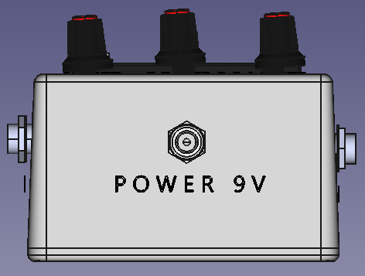

Figure : Back View

### Guitar In

On the right side of the unit is a 1/4" TR / 6.3 mm mono jack port for the guitar audio in signal.

In most cases, the fuzz will sound best, when this unit will be connected before other guitar effect pedals or modules.

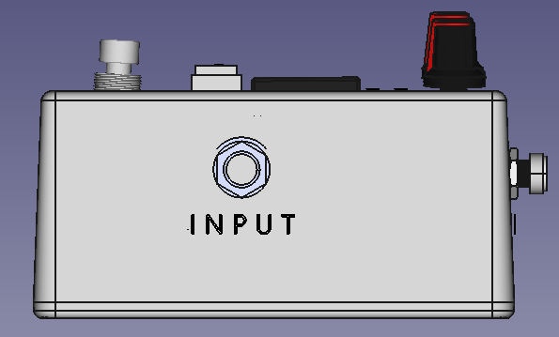

Figure : Right View

### Guitar Out

On the left side of the unit is a 1/4" TR / 6.3 mm mono jack port for the guitar audio out signal.

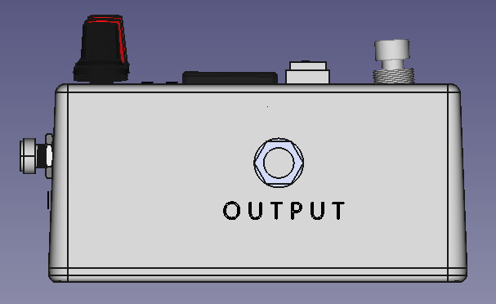

Figure : Left View

## Digital Part

### Introduction

The display with the three push buttons and the foot switch, are used to select the components, and to perform specific functions. These are shown by the yellow markings in the figure below.

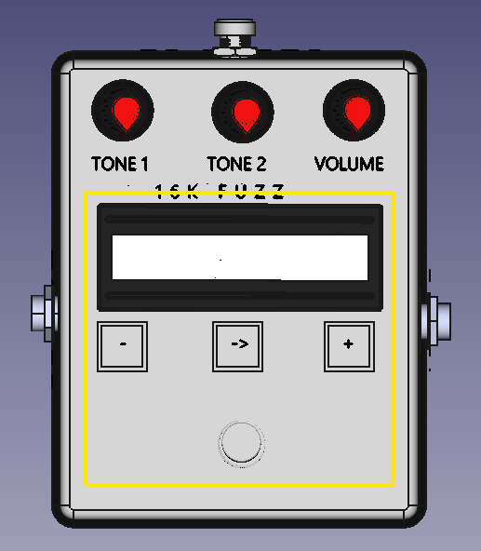

Figure 5: Top View / Digital Part

The different screens which are displayed are called Modes.

Under the LCD screen, three buttons are visible and the table show the name of the push buttons used in the remainder of this manual.

|  |  |  |
| --- | --- | --- |
| **Button** | **Name** | **Default function** |
| - | Decrease | Decrease the current value |
| -> | Enter | Go to the next mode |
| + | Increase | Increase the current value |

Table : Push Buttons

The function of teach button depends on the mode, but the default function is described in the list.

The following modes are available, some of them are special, meaning the ‘Enter button’ is **not** used to enter this mode.

|  |  |
| --- | --- |
| **Mode** | **Special** |
| Preset Selection | No |
| Capacitor A | No |
| Transistor B | No |
| Transistor C | No |
| Capacitor D | No |
| Presets Memory | No |
| Lock/Unlock | Yes |
| Bypass | Yes |

Table : Modes

In the following paragraphs, each mode will be explained in detail.

### Preset Selection Mode

When starting up the unit, it will start up in this mode. This mode can be recognized by the cursor (gray box) blinking over the ‘:’ symbol after number 80 in the example below, and by the second line ‘Preset: ‘, followed by the same number.

80**:**A7 B16 C16 D8

Preset: 80

There are 100 presets available, from 00 to 99. Each preset contains two capacitors (A and D), two transistors (B and C). In the first line of the display, the indices of each selected capacitor and selected transistor for this preset are shown. In paragraph 4.3 (Capacitors) and paragraph 4.4 (Transistors), the type of a capacitor and transistor can be looked up. Also, when entering a specific capacitor or transistor mode will show the type (see next paragraphs).

In the second line, the number of the preset is repeated for clearity.

With the decrease resp. increase button, the current preset can be decreased or increased between values 00 and 99.

Keeping one of these buttons pressed, will make the value decrease or increase faster.

When the value reaches 00 and the decrease button is pressed (or held), the following message is briefly shown:

Minimum value

reached

When the value reaches 99 and the increase button is pressed (or hold), the following message is briefly shown:

Maximum value

reached

Pressing the Enter (middle) button, changes the mode to Capacitor A Mode.

### Capacitor A Mode

In this mode, the type for capacitor A can be selected and the display shows the capacitor A index and type:

80:**A**8 B01 C16 D8

Cap A8: 22 uF

The cursor blinking the character ‘A’ shows that Capacitor A is selected to be changed. The decrease and increase push buttons can be used for this.

The minimum value is 1, and the maximum value is 8. When exceeded the Minimum/Maximum value reached messages are shown.

Pressing the Enter push button will change the mode to Transistor B Mode.

### Transistor B Mode

In this mode, the type for Transistor B can be selected and the display shows the Transistor B index and type:

80:A8 **B**01 C16 D8

Tr.B01:MMBT2222A

The cursor blinking the character ‘B’ shows that Transistor B is selected to be changed. The decrease and increase push buttons can be used for this.

The minimum value is 1, and the maximum value is 16. When exceeded the Minimum/Maximum value reached messages are shown.

Pressing the Enter push button will change the mode to Transistor C Mode.

### Transistor C Mode

This mode is similar to the previous mode (Transistor B Mode), except it shows and changes Transistor C.

Pressing the Enter push button will change the mode to Capacitor D Mode.

### Capacitor D Mode

This mode is similar to the Capacitor A Mode, except it shows and changes Capacitor D.

Pressing the Enter push button will change the mode to Presets Memory Mode.

### Presets Memory Mode

In this mode, the presets can be loaded or stored in memory that is preserved, even when the unit is switched off (by removing the DC power supply cable or by powering off the power supply supplying this unit).

Besides storing all 100 presets (including its selected components: Capacitor A, Transistor B, Transistor C and Capacitor D), also the currently selected preset is stored. This means when the unit is powered up next time, it will start with the last selected preset (when saved for the last time).

The following display is shown:

PRESETS MEMORY

LOAD STORE

Note that the LOAD and STORE text will be shown just above the Decrease and Increase push buttons.

When selecting LOAD (decrease button), the current presets will be overwritten with the presets saved last. Only use this, when you made changes you want to revert. Also, the last selected preset will be reverted. When the presets are successfully loaded, the display shows briefly a message:

Presets loaded

into memory

When this is not possible (i.e. when there are no presets saved), the following messages will be shown. When this happens, save your presets first.

Error while

loading presets

When selecting STORE (increase button), the unit checks if any changes have been made since the last time the presets have been saved. This check will be done, even when the unit has been switched off meanwhile. If no presets are changed, or when the selected preset has not changed, the display shows briefly a message:

No presets

changed

When at least one preset or the current preset selection has been changed, ALL presets will be stored. When successfully are successfully stored, the display shows briefly a message:

Presets stored

into memory

In case of an error during saving presets, the following screen is shown. The unit needs to be serviced or malfunctions if this happens.

Error while

loading presets

Pressing the Enter push button will change the mode back to Preset Selection Mode.

### Lock/Unlock Mode

While playing guitar and the Bypass (foot) switch is used, accidentally one of the push buttons could be pressed.

To prevent changing the current preset, component types, or loading/storing presets, the three push buttons can be locked.

Locking can be activated by pressing the Decrease and Increase button for 1 second. The following screen is shown:

SCREEN LOCKED

HOLD ---- HOLD

The push buttons now will not have their normal functionality.

To release the Lock Mode, press the Decrease and Increase push buttons simultaneously again for one second (or keep them pressed after entering Lock Mode), and the unit will unlock. The previously selected mode will be displayed again.

Prevent pressing one button earlier than the second button to prevent unwanted decreasing/increasing of the current mode parameter.

Although locking/unlocking works in the Presets Memory mode, prevent accidentally loading all presets when the intention is to lock the screen.

### Bypass Mode

The bypass knob is a foot switch and is used to bypass (switch off) the unit, or to activate the fuzz sound (switch on).

When bypassed, the signal will go directly from INPUT to OUTPUT without any sound alteration. The display backlight will be disabled and the following text is shown:

BYPASSED. PRESS

FOOT SWITCH

When the bypass foot switch is pressed again, the fuzz will be activated again and the backlight will be enabled. The screen will revert to the mode before getting into bypass mode.

## Analog Part

The three dial knobs at the top of the unit are used for controlling the analog circuit of the unit. These are shown by the yellow markings in the figure below.

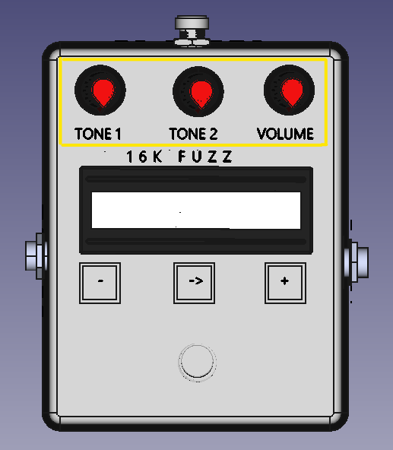

Figure : Top View / Analog Part

### Tone 1 Dial Knob

This dial knob is used to change the amount of signal related to Transistor B.

### Tone 2 Dial Knob

This dial knob is used to change the amount of signal related to Transistor C.

### Volume Dial Knob

This knob is used to set the volume from off (left) to maximum (right).

# Technical Specifications

**Features**

Number of capacitors for fuzz: 2 x 8

Number of transistors for fuzz: 2 x 16

Number of presets: 100

Storage lifetime: > 300,000 amount of stores, guaranteed

20 years

**Dimensions/Weight**

Dimensions:

Length: 120 mm

Width: 94 mm

Height: 62 mm

Weight: 300 grams (TODO lbs)

**Input/Output**

Guitar Input 1/4” Unbalanced (TS) / 6.3 mm Mono Jack

Guitar Output 1/4” Unbalanced (TS) / 6.3 mm Mono Jack

Maximum Output 9V

**Power**

Power Consumption: Active: max. < 230 mA @ 9 VDC)

Power Requirements: 9 VDC External Adapter

Product specifications are subject to change without notice.

# Contact Information

Name: Michel Keijzers

Email: [michelkeijzers@hotmail.com](mailto:michelkeijzers@hotmail.com)

# Compliances & Warranty

Since this product will not be released commercially, the following compliances are not measured, neither certificated:

* Safety
* Low Voltage Directive 2006 /95 /EC
* EMC Directive 2004 /108 /EC
* RoHS Directive 2011 /65 /EC
* WHEE Directive 2002 /96 /EC
* EC Regulation 278 /2009
* FCC (part 15, class B device)

Since this product will not be released commercially, warranty depends on the willingness of the designer.